**Docker and OCI Runtimes**

The objective of this blog post is to deep dive into the various aspcts of OCI aka [Open Container Initiative](https://www.opencontainers.org/) and how Docker fits in there.

# ****What is Open Container Initiative (OCI)?****

* The **Open Container Initiative** (**OCI**) is a [Linux Foundation](https://www.linuxfoundation.org/) project to design open standards for containers.
* Established in June 2015 by Docker and other leaders in the container industry.
* OCI currently contains two specifications: the Runtime Specification ([runtime-spec](http://www.github.com/opencontainers/runtime-spec)) and the Image Specification ([image-spec](http://www.github.com/opencontainers/image-spec)).
* OCI runtime spec defines how to run the OCI image bundle as a container.
* OCI image spec defines how to create an OCI Image, which includes an [image manifest](https://github.com/opencontainers/image-spec/blob/master/manifest.md), a [filesystem (layer) serialization](https://github.com/opencontainers/image-spec/blob/master/layer.md), and an [image configuration](https://github.com/opencontainers/image-spec/blob/master/config.md).

# What are the various Container Runtimes?

Some of the the popular container runtimes are below ones:

* [**containerd**](https://containerd.io/): A CNCF project, it manages the complete container lifecycle of its host system that includes image management, storage and container lifecycle, supervision, execution and networking.
* [**lxc**](https://linuxcontainers.org/): LXC provides OS level virtualization through a virtual environment that has its own process and network space, it uses linux cgroups and namespaces to provide the isolation.
* [**runc**](https://github.com/opencontainers/runc)**:**runc is a CLI tool for spawning and running containers according to the OCI specification. It was developed by Docker Inc and donated to OCI as the first OCI runtime-spec compliant reference implementation.
* [**cri-o**](https://cri-o.io/)**:**CRI-O is an implementation of the Kubernetes CRI (Container Runtime Interface) to enable using OCI (Open Container Initiative) compatible runtimes. It is a lightweight alternative to using Docker as the runtime for Kubernetes.
* [**rkt**](https://coreos.com/rkt/)**:** rkt is an application container engine developed by

*So in a nutshell the container runtimes does some or all of the below tasks:*

* Container image management
* Container lifecycle management
* Container creation
* Container resource management

*Some of the runtimes like “rkt” does most of the tasks by itself, where as runtime like “containerd” does some of the high level functions and uses others like “runc” for some of the low level tasks.*

# Okay, So what is Docker then?

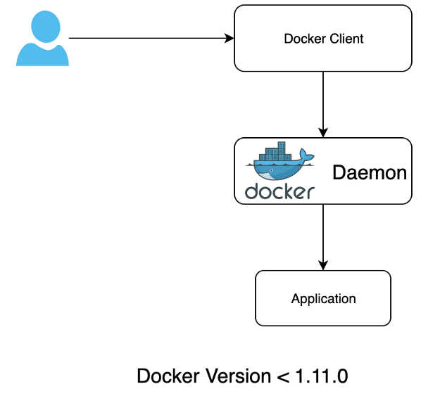

Docker engine used to be a single monolith before version 1.11.0, the engine was responsible for all the aspects of container management like image management, lifecycle, creation, resource managment etc.

In docker version 1.11.0 major restructuring happened in the Docker engine as below:

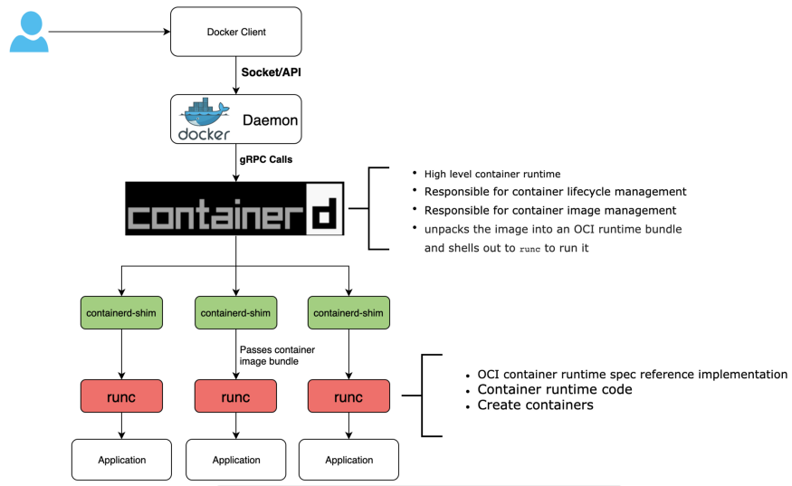

* The low level container runtime features were moved to a different project called runc, it was the first OCI runtime spec reference implementation. Docker donated it to OCI.
* Docker also created the “containerd” project for the supervision of the containers spawns out using “runc”
* containerd has full support for starting OCI bundles and managing their lifecycle.
* Docker published two blog posts behind the rational for createion of “[runc](https://www.docker.com/blog/runc/)” and “[containerd](https://www.docker.com/blog/docker-containerd-integration/)”.

So, I have a vagrant CentOS box and have installed docker in it, the running docker processes looks like below:

[root@localhost ~]# ps aux | grep dockerroot 4499 0.1 4.6 575580 23296 ? Ssl 05:04 0:00 /usr/bin/dockerd-current **--add-runtime docker-runc=/usr/libexec/docker/docker-runc-current** **--default-runtime=docker-runc** --exec-opt native.cgroupdriver=systemd --userland-proxy-path=/usr/libexec/docker/docker-proxy-current --init-path=/usr/libexec/docker/docker-init-current --seccomp-profile=/etc/docker/seccomp.json --selinux-enabled --log-driver=journald --signature-verification=false --storage-driver overlay2root 4504 0.0 2.1 284632 10740 ? Ssl 05:04 0:00 **/usr/bin/docker-containerd-current -l unix:///var/run/docker/libcontainerd/docker-containerd.sock** --metrics-interval=0 --start-timeout 2m --state-dir /var/run/docker/libcontainerd/containerd --shim docker-containerd-shim --runtime docker-runc --runtime-args --systemd-cgroup=true  
root 4696 0.0 0.1 12520 984 pts/0 R+ 05:06 0:00 grep --color=auto docker

Its very evident here that docker engine under the hood running containerd and runc as container runtimes.

# Playing around with containerd

As mentioned above containerd is a high level runtime and can be installed on any linux machine following the instructions [here](https://github.com/containerd/cri/blob/master/docs/installation.md)

[root@localhost ~]# service containerd status  
Redirecting to /bin/systemctl status containerd.service  
● containerd.service - containerd container runtime  
 Loaded: loaded (/etc/systemd/system/containerd.service; disabled; vendor preset: disabled)  
 Active: active (running) since Tue 2019-11-05 05:47:29 UTC; 2min 56s ago  
 Docs: [https://containerd.io](https://containerd.io/)  
 Process: 24741 ExecStartPre=/sbin/modprobe overlay (code=exited, status=0/SUCCESS)  
 Main PID: 24742 (containerd)  
 Tasks: 19  
 Memory: 116.9M  
 CGroup: /system.slice/containerd.service  
 ├─24399 containerd-shim -namespace default -workdir /var/lib/containerd/io.containerd.r...  
 └─24742 /usr/local/bin/containerd

When we install containerd it installs the downstream dependencies as well like:

* runc: to run containers
* ctr: A CLI for containerd
* containerd-shim: to support daemonless containers

**What all I can do using containerd?**

* Manage images (like downloading from docker registry)
* Manage containers (like create and running containers)
* Manage namespaces

**How to interact with containerd?**

We will be using the ctr cli for containerd.

* **Downloading images:**

[root@localhost ~]# ctr images pull docker.io/library/python:3  
docker.io/library/python:3: total: 333.1 (5.6 MiB/s)  
unpacking linux/amd64 sha256:514a95a32b86cafafefcecc28673bb647d44c5aadf06203d39c43b9c3f61ed52...  
done

* **Listing images:**

[root@localhost ~]# ctr images ls  
REF TYPE DIGEST SIZE PLATFORMS LABELS  
docker.io/library/python:3 application/vnd.docker.distribution.manifest.list.v2+json sha256:514a95a32b86cafafefcecc28673bb647d44c5aadf06203d39c43b9c3f61ed52 333.1 MiB linux/386,linux/amd64,linux/arm/v5,linux/arm/v7,linux/arm64/v8,linux/ppc64le,linux/s390x,windows/amd64 -docker.io/library/redis:latest application/vnd.docker.distribution.manifest.list.v2+json sha256:fe80393a67c7058590ca6b6903f64e35b50fa411b0496f604a85c526fb5bd2d2 34.2 MiB linux/386,linux/amd64,linux/arm/v5,linux/arm/v7,linux/arm64/v8,linux/ppc64le,linux/s390x

* **Running and listing containers:**

[root@localhost ~]# ctr run -d docker.io/library/python:3 python[root@localhost ~]# ctr containers ls  
CONTAINER IMAGE RUNTIME  
python docker.io/library/python:3 io.containerd.runtime.v1.linux

## **What is this containerd-shim (refer the docker image above)?**

So based on above command, we start a python3 container using containerd, we know that containerd doesn’t run the actual container, its the runc that responsible for running the container.

* The shim allows for daemonless containers. It basically sits as the parent of the container’s process to facilitate a few things.
* It allows the runtimes, i.e. runc, to exit after it starts the container. This way we don’t have to have the long running runtime processes for containers.
* It allows the container’s exit status to be reported back to a higher level tool like docker without having the actual parent of the container’s process running.

This is very much evident from the below command, we do see containerd running but no runc, instead we have the containerd-shim process running for the python container.

[root@localhost ~]# ps aux | grep containerdroot 24742 2.3 8.0 492276 40096 ? Ssl 05:47 0:28 /usr/local/bin/containerdroot 24829 0.0 0.7 109100 3940 ? Sl 06:01 0:00 **containerd-shim** -namespace default -workdir /var/lib/containerd/io.containerd.runtime.v1.linux/default/**python** -address /run/containerd/containerd.sock -containerd-binary /usr/local/bin/containerd

Note: To know more about it please watch this excellent youtube [video](https://www.youtube.com/watch?v=VWuHWfEB6ro) by Michael Crosby.

# Playing around with runc

So runc is the low level container runtime (based on OCI [runtime-spec](https://github.com/opencontainers/runtime-spec/blob/master/spec.md)) whose only job is to run containers using OCI [image-spec](https://github.com/opencontainers/image-spec/blob/master/spec.md) based resource bundle.

In the above section we already saw how containerd can be used to start and run containers and under the good it uses containerd-shim to run the container using runc

What that means is we should be able to run a container manually using runc as well.

runc binary got installed as containerd dependency.

[root@localhost ~]# runc --help  
NAME:  
 runc - Open Container Initiative runtimerunc is a command line client for running applications packaged according to  
the Open Container Initiative (OCI) format and is a compliant implementation of the  
Open Container Initiative specification.runc integrates well with existing process supervisors to provide a production  
container runtime environment for applications. It can be used with your  
existing process monitoring tools and the container will be spawned as a  
direct child of the process supervisor.Containers are configured using bundles. A bundle for a container is a directory  
that includes a specification file named "config.json" and a root filesystem.  
The root filesystem contains the contents of the container.To start a new instance of a container:# runc run [ -b bundle ] <container-id>Where "<container-id>" is your name for the instance of the container that you  
are starting. The name you provide for the container instance must be unique on  
your host. Providing the bundle directory using "-b" is optional. The default  
value for "bundle" is the current directory.

Based on above documentation all we need is an OCI image-spec based bundle (a spec file named config.json and the container image root filesystem) to run a container.

Lets create the container image root filesystem:

[root@localhost rootfs]# mkdir -p alpine/rootfs  
[root@localhost rootfs]# cd alpine  
[root@localhost alpine]# docker export $(docker run -d alpine) | tar -C rootfs -xv[root@localhost alpine]# pwd  
/root/alpine/rootfs/alpine  
[root@localhost alpine]# ls rootfs/  
bin dev etc home lib media mnt opt proc root run sbin srv sys tmp usr var

We just used docker here to run a alpine image and then exported the container as tarball. Extracting the tarball gave us the root filesystem for the alpine image.

Now lets create the runtime-spec config file:

[root@localhost alpine]# runc spec  
[root@localhost alpine]# cat config.json  
{  
 "ociVersion": "1.0.1-dev",  
 "process": {  
 "terminal": true,  
 "user": {  
 "uid": 0,  
 "gid": 0  
 },  
 "args": [  
 "sh"  
 ],  
 "env": [  
 "PATH=/usr/local/sbin:/usr/local/bin:/usr/sbin:/usr/bin:/sbin:/bin",  
 "TERM=xterm"  
 ],  
 "cwd": "/",  
 ... ...  
 "readonlyPaths": [  
 "/proc/asound",  
 "/proc/bus",  
 "/proc/fs",  
 "/proc/irq",  
 "/proc/sys",  
 "/proc/sysrq-trigger"  
 ]  
 }  
}

Now to run a container is as simple as below command:

[root@localhost alpine]# runc run alpine-container  
/ #  
/ #  
/ # pwd  
/  
/ # echo "runc started this container using the rootfs of alpine"  
runc started this container using the rootfs of alpine  
/ #

Based on the spec config.json file, the default command is sh for the image, so we entered into the shell of the container.

What we can summarize here is that the whole container runtimes under OCI is very flexible and pluggable, as long we are meeting the image-spec and runtime-spec requirements we can have custom runtimes for containers.

Docker is no longer a monolith and under the hood its using the containerd and runc runtimes to manage containers.

containerd enables us to have container ecosystem without docker, for example cri-o in Kubernetes world can have the container runtime without docker.

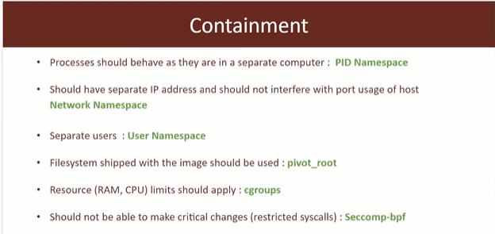

https://attackdefense.pentesteracademy.com/listing?labtype=container-security-bootcamp&subtype=container-security-bootcamp-recordings

* 1. Docker container breakout due to misconfiguration
* Mounting docker sockets
* Providing –privileged container
* Sharing host namespace with container
* Linux capabilities
  1. Docker Threatscape due to docker host